**LAN Backup System:**

Architecture diagram.

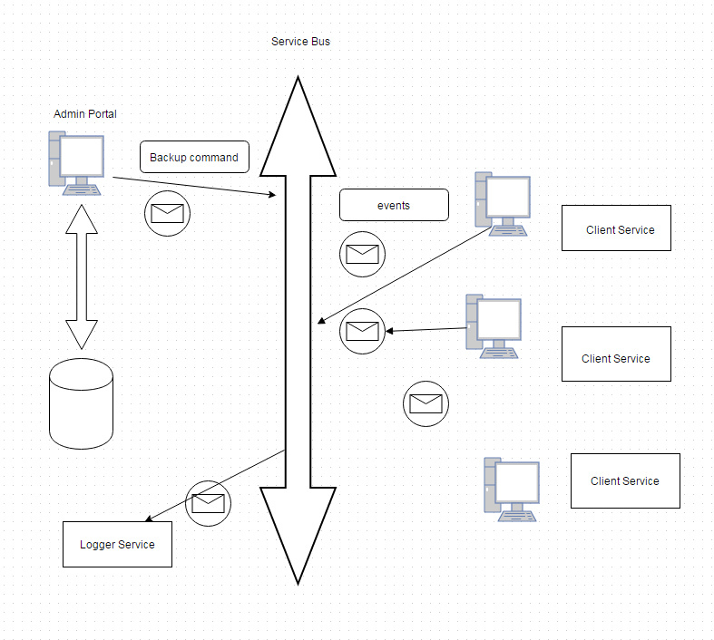

Components of the system:

Admin Portal, Client service, Logger service and Data store.

Admin portal, client service and logger service are connected through NserviceBus.

Schedule job commands are sent to the client service from admin portal through NServiceBus. Commands get logged in the msmq at the client machine and picked up by the client service to execute.

While executing the command, client service publishes series of events about the logs and statuses.

Admin portal, Logger service are subscribed to these events from client service.

Logger service logs the events to the db.

Admin portal gets the event and update the UI for the status.

We use Microsoft sync framework for synching/uploading files from source computer to destination computer.

Admin portal user screen:

